

**Project Report**

**Design a full-fledged network for an organization with multiple subnets.**

**Course Title: Computer Networks**

**Course Code: CSE405**

**Section: 03**

**Semester: Spring-24**

**Submitted by:**

Al-Imam Uddin

2021-3-60-260

**Submitted to:**

**Dr. Anisur Rahman (MAR)**

Associate Professor

Department of Computer Science and Engineering

Proctor

East West University

Submission Date: 8/6/2024

**Title:**

Designing a Full-fledged Network for an Organization with Multiple Subnets.

**Preface:**

Apex University, is an enterprise like East West University, owns many computers, with a complex network infrastructure. Apart from wired internet access to all the classrooms, labs, employee PCs, library and other administrative and academic wings, the university also provides wireless internet access for every campus. On top of that the university runs complex networked systems to support several of its business process like admissions, advising, results, eTender, library management, accounts and so on.

Now, The task is to create a complete model of a complex network by discovering the interconnectivity of the systems and subnetworks, which will reflect the University of Scholars structure and facilities, features within the network.

**Tools:**

**Components Used:**

* 2811- Router
* Wireless access point
* Straight Through Cable
* Serial DCE cables
* 2960-24TT Switches
* PC as end devices
* DNS Server
* Web Server
* DHCP server
* Smart Phone, Tablet

**Software Used:**

* Cisco Packet Tracer version 8.1.1.0022
* **Network Summary:**
* University’s full network has covered with 7 campuses with 7 routers.
* All the Ip address set by one DHCP server automatically & DNS server is use to locate Web server and HTML code is use to modify the web page.

**Physical Diagram:** ALL Campus.

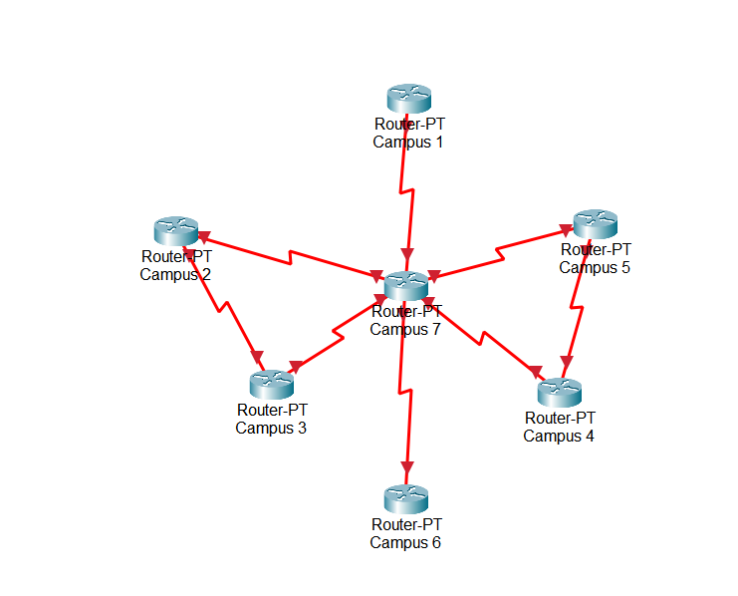

Figure 1: Network Model created in Cisco Packet Tracer

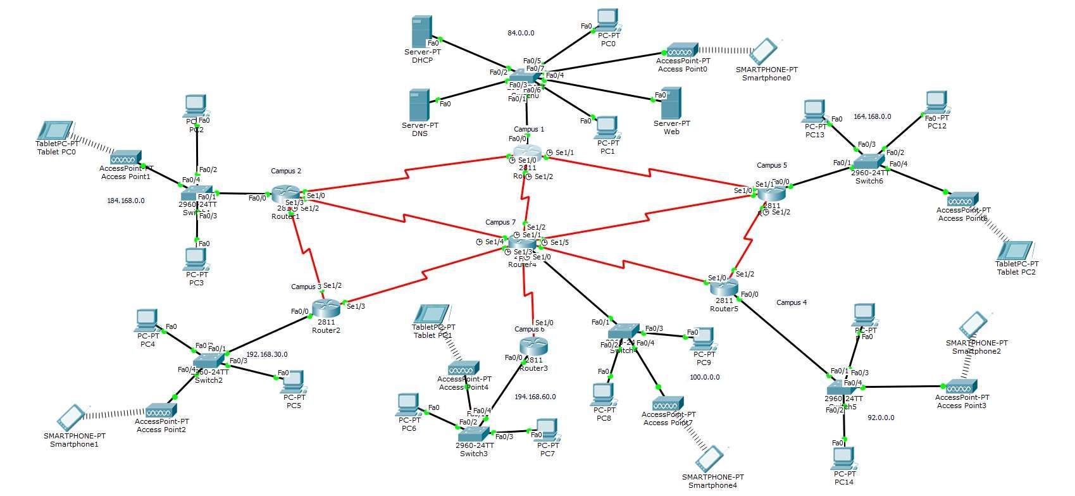

Figure 2: Network Model created in Cisco Packet Tracer

**Design Issues:**

Actually, there are no Design issues all the connections, servers, and End devices are working perfectly.

**The classes that are used:**

1. Class A: It is used for all end device networks.
2. Class B & Class C: It is used for router-to-router connection networks.

**Limitations:**

It's quite a complicated network. It may be difficult to maintain this network. It is difficult to add more university networks quickly. Hands-on configuration is required for additional networks. A maximum amount of hosts can be supported by the network.

**Lines of Code:**

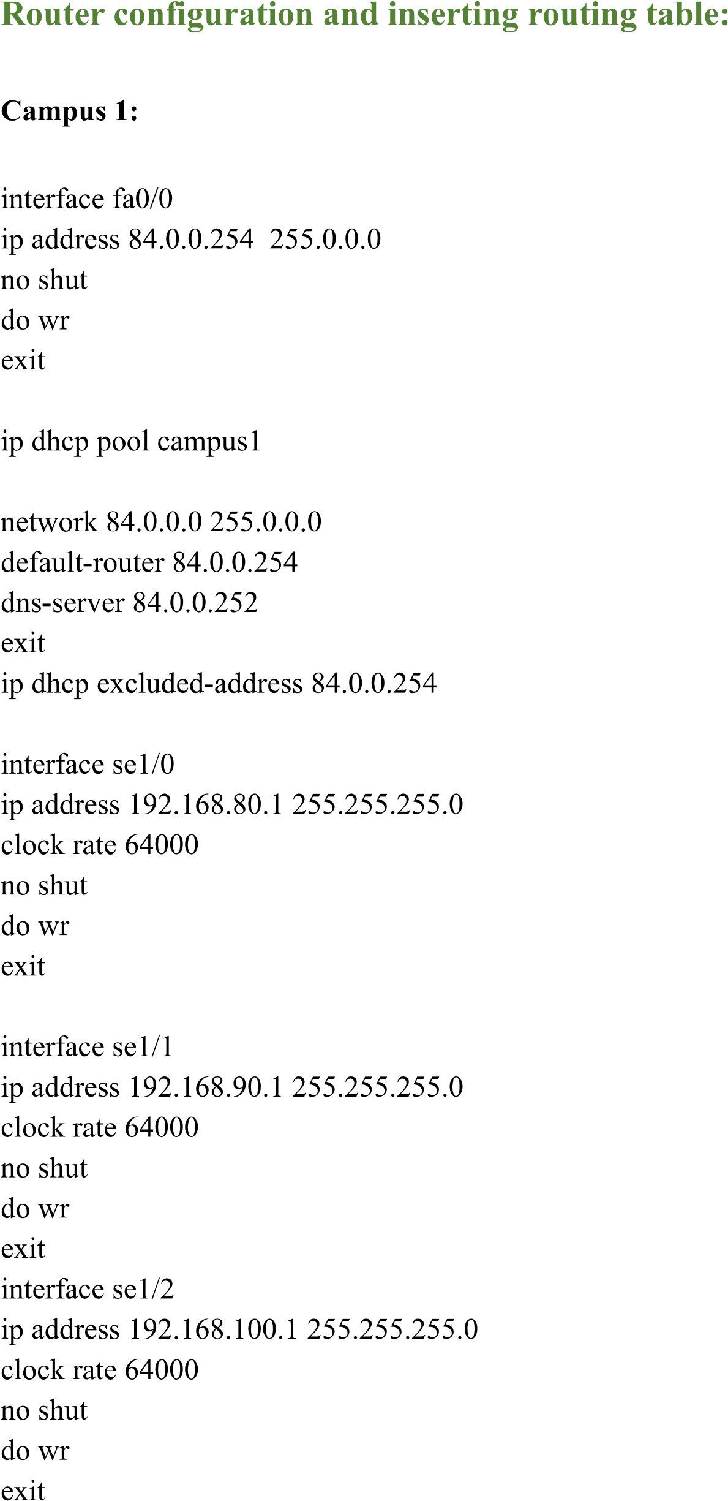

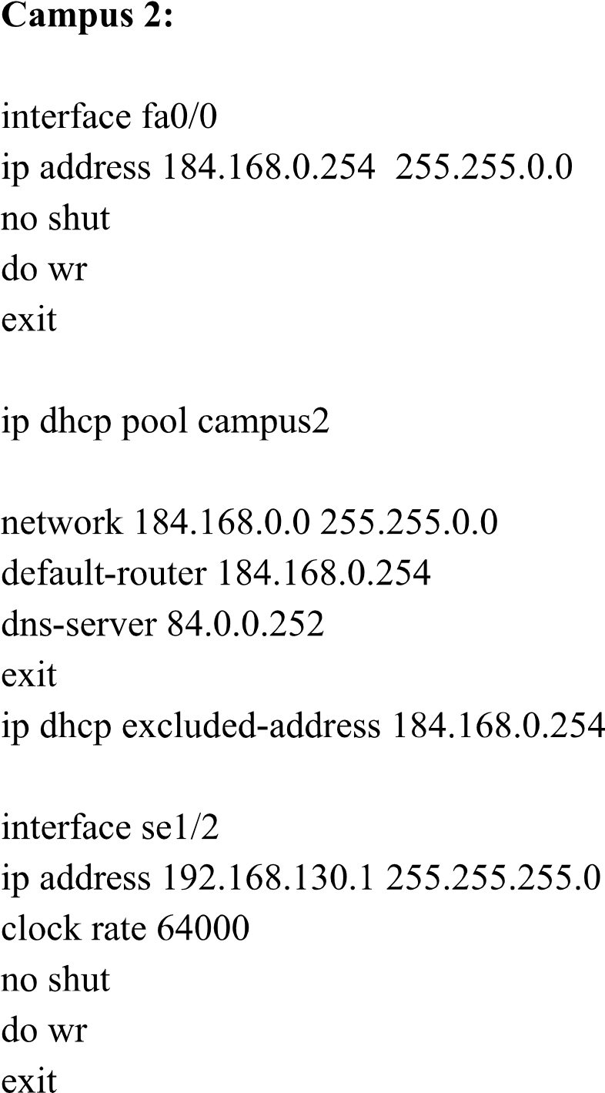

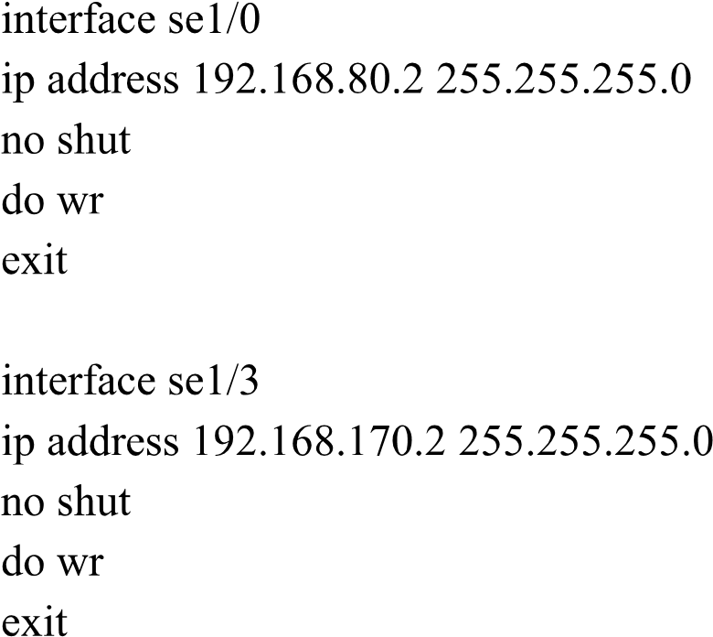

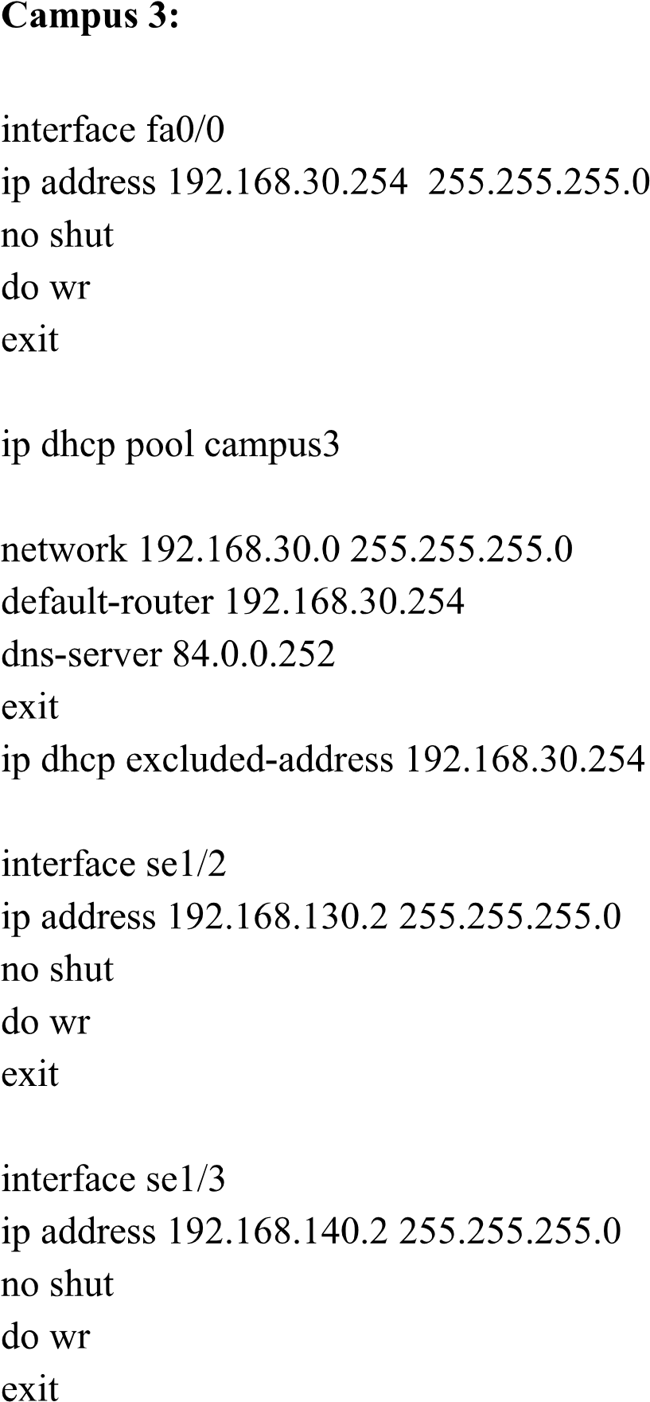

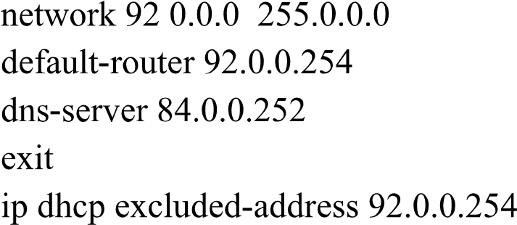

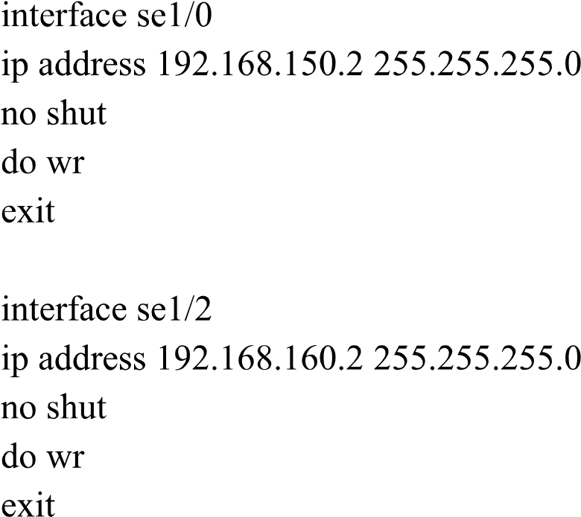



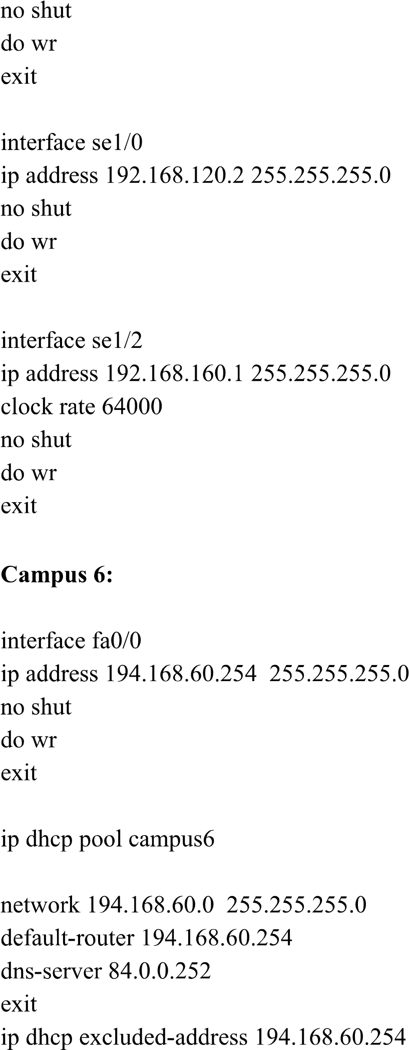

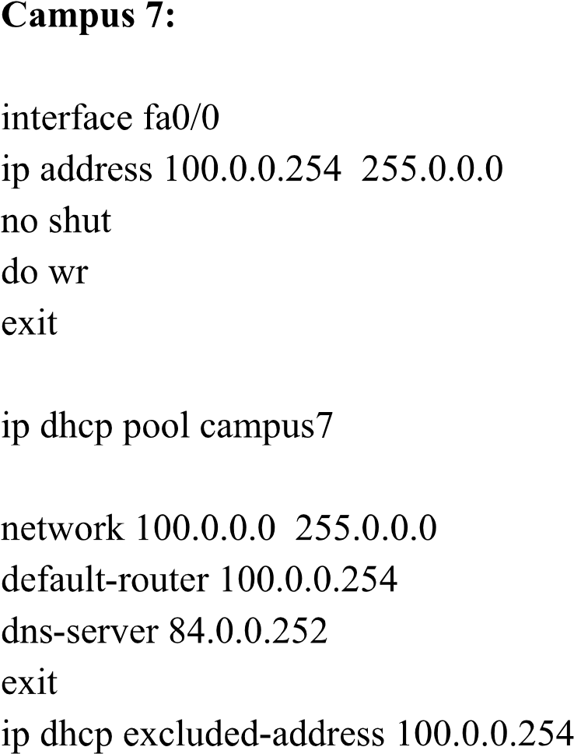

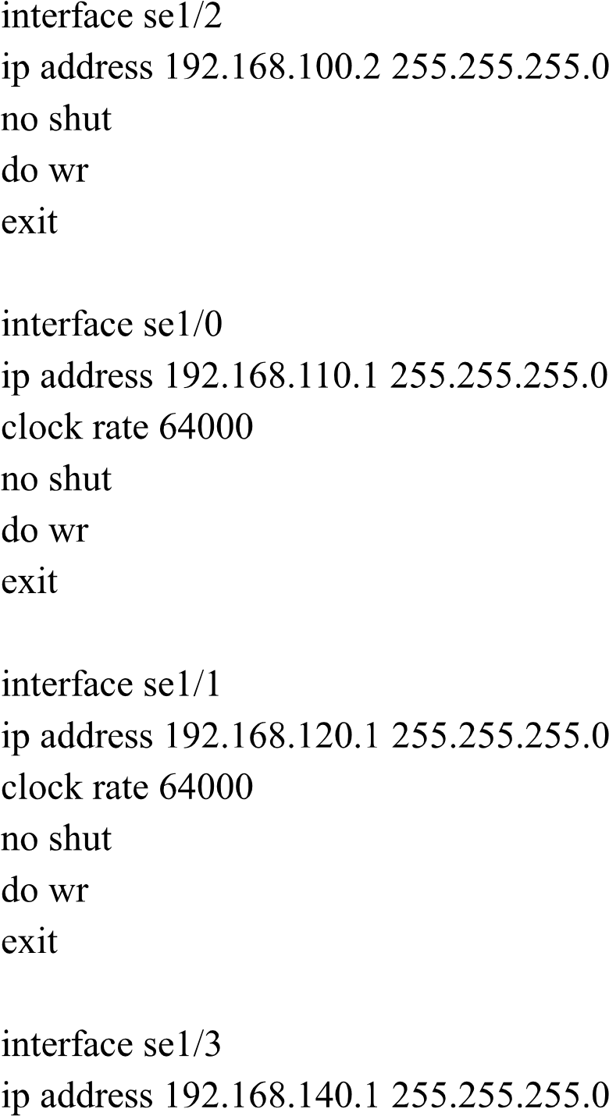

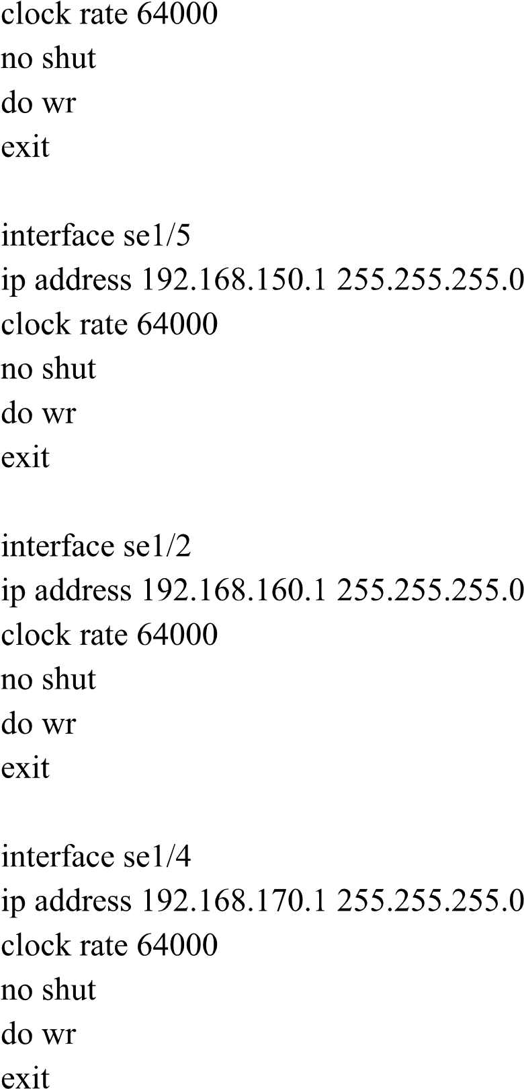

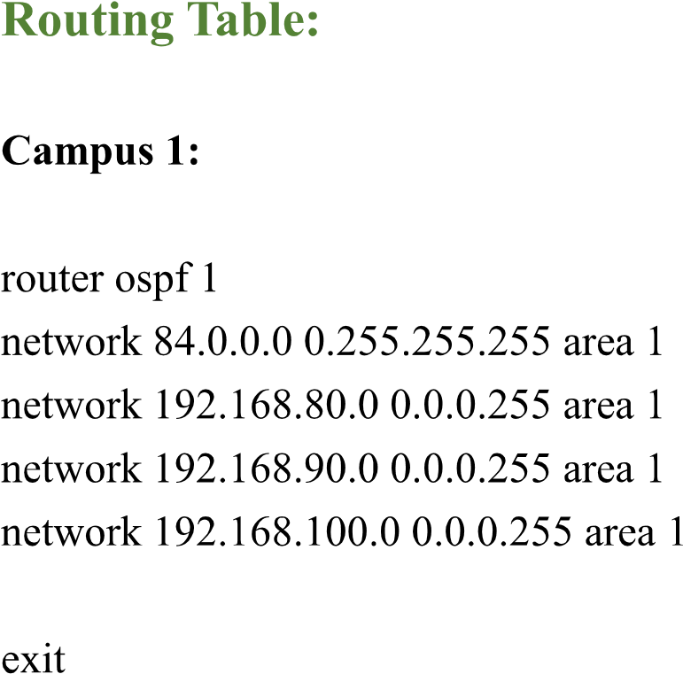

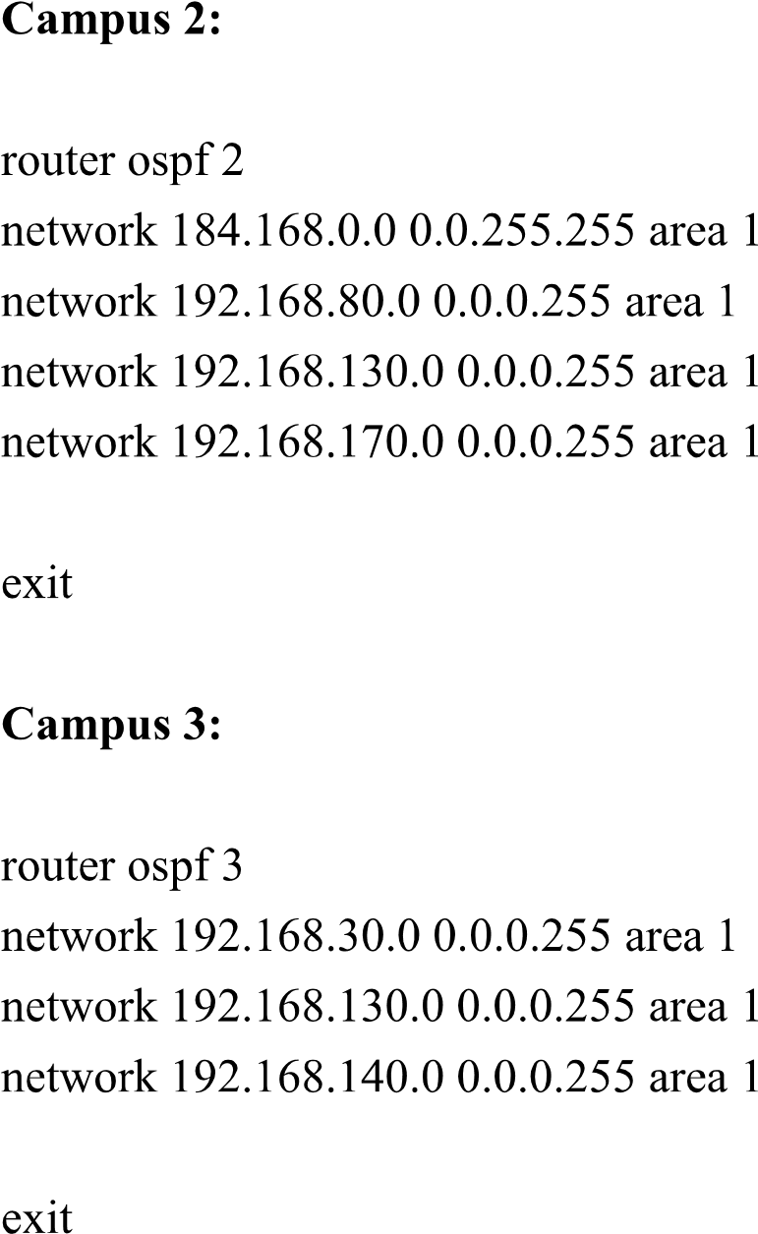

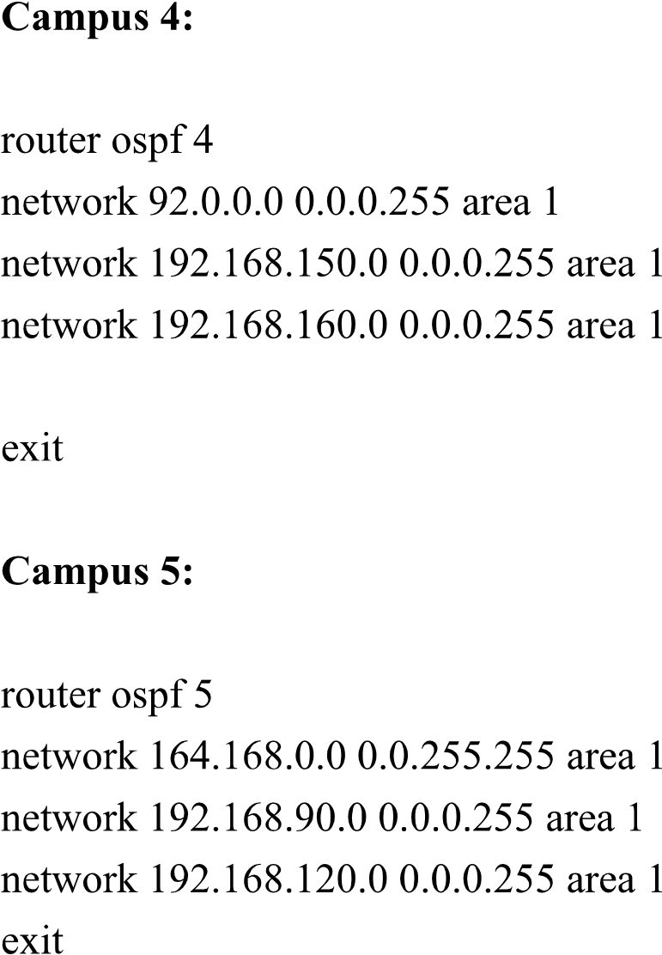

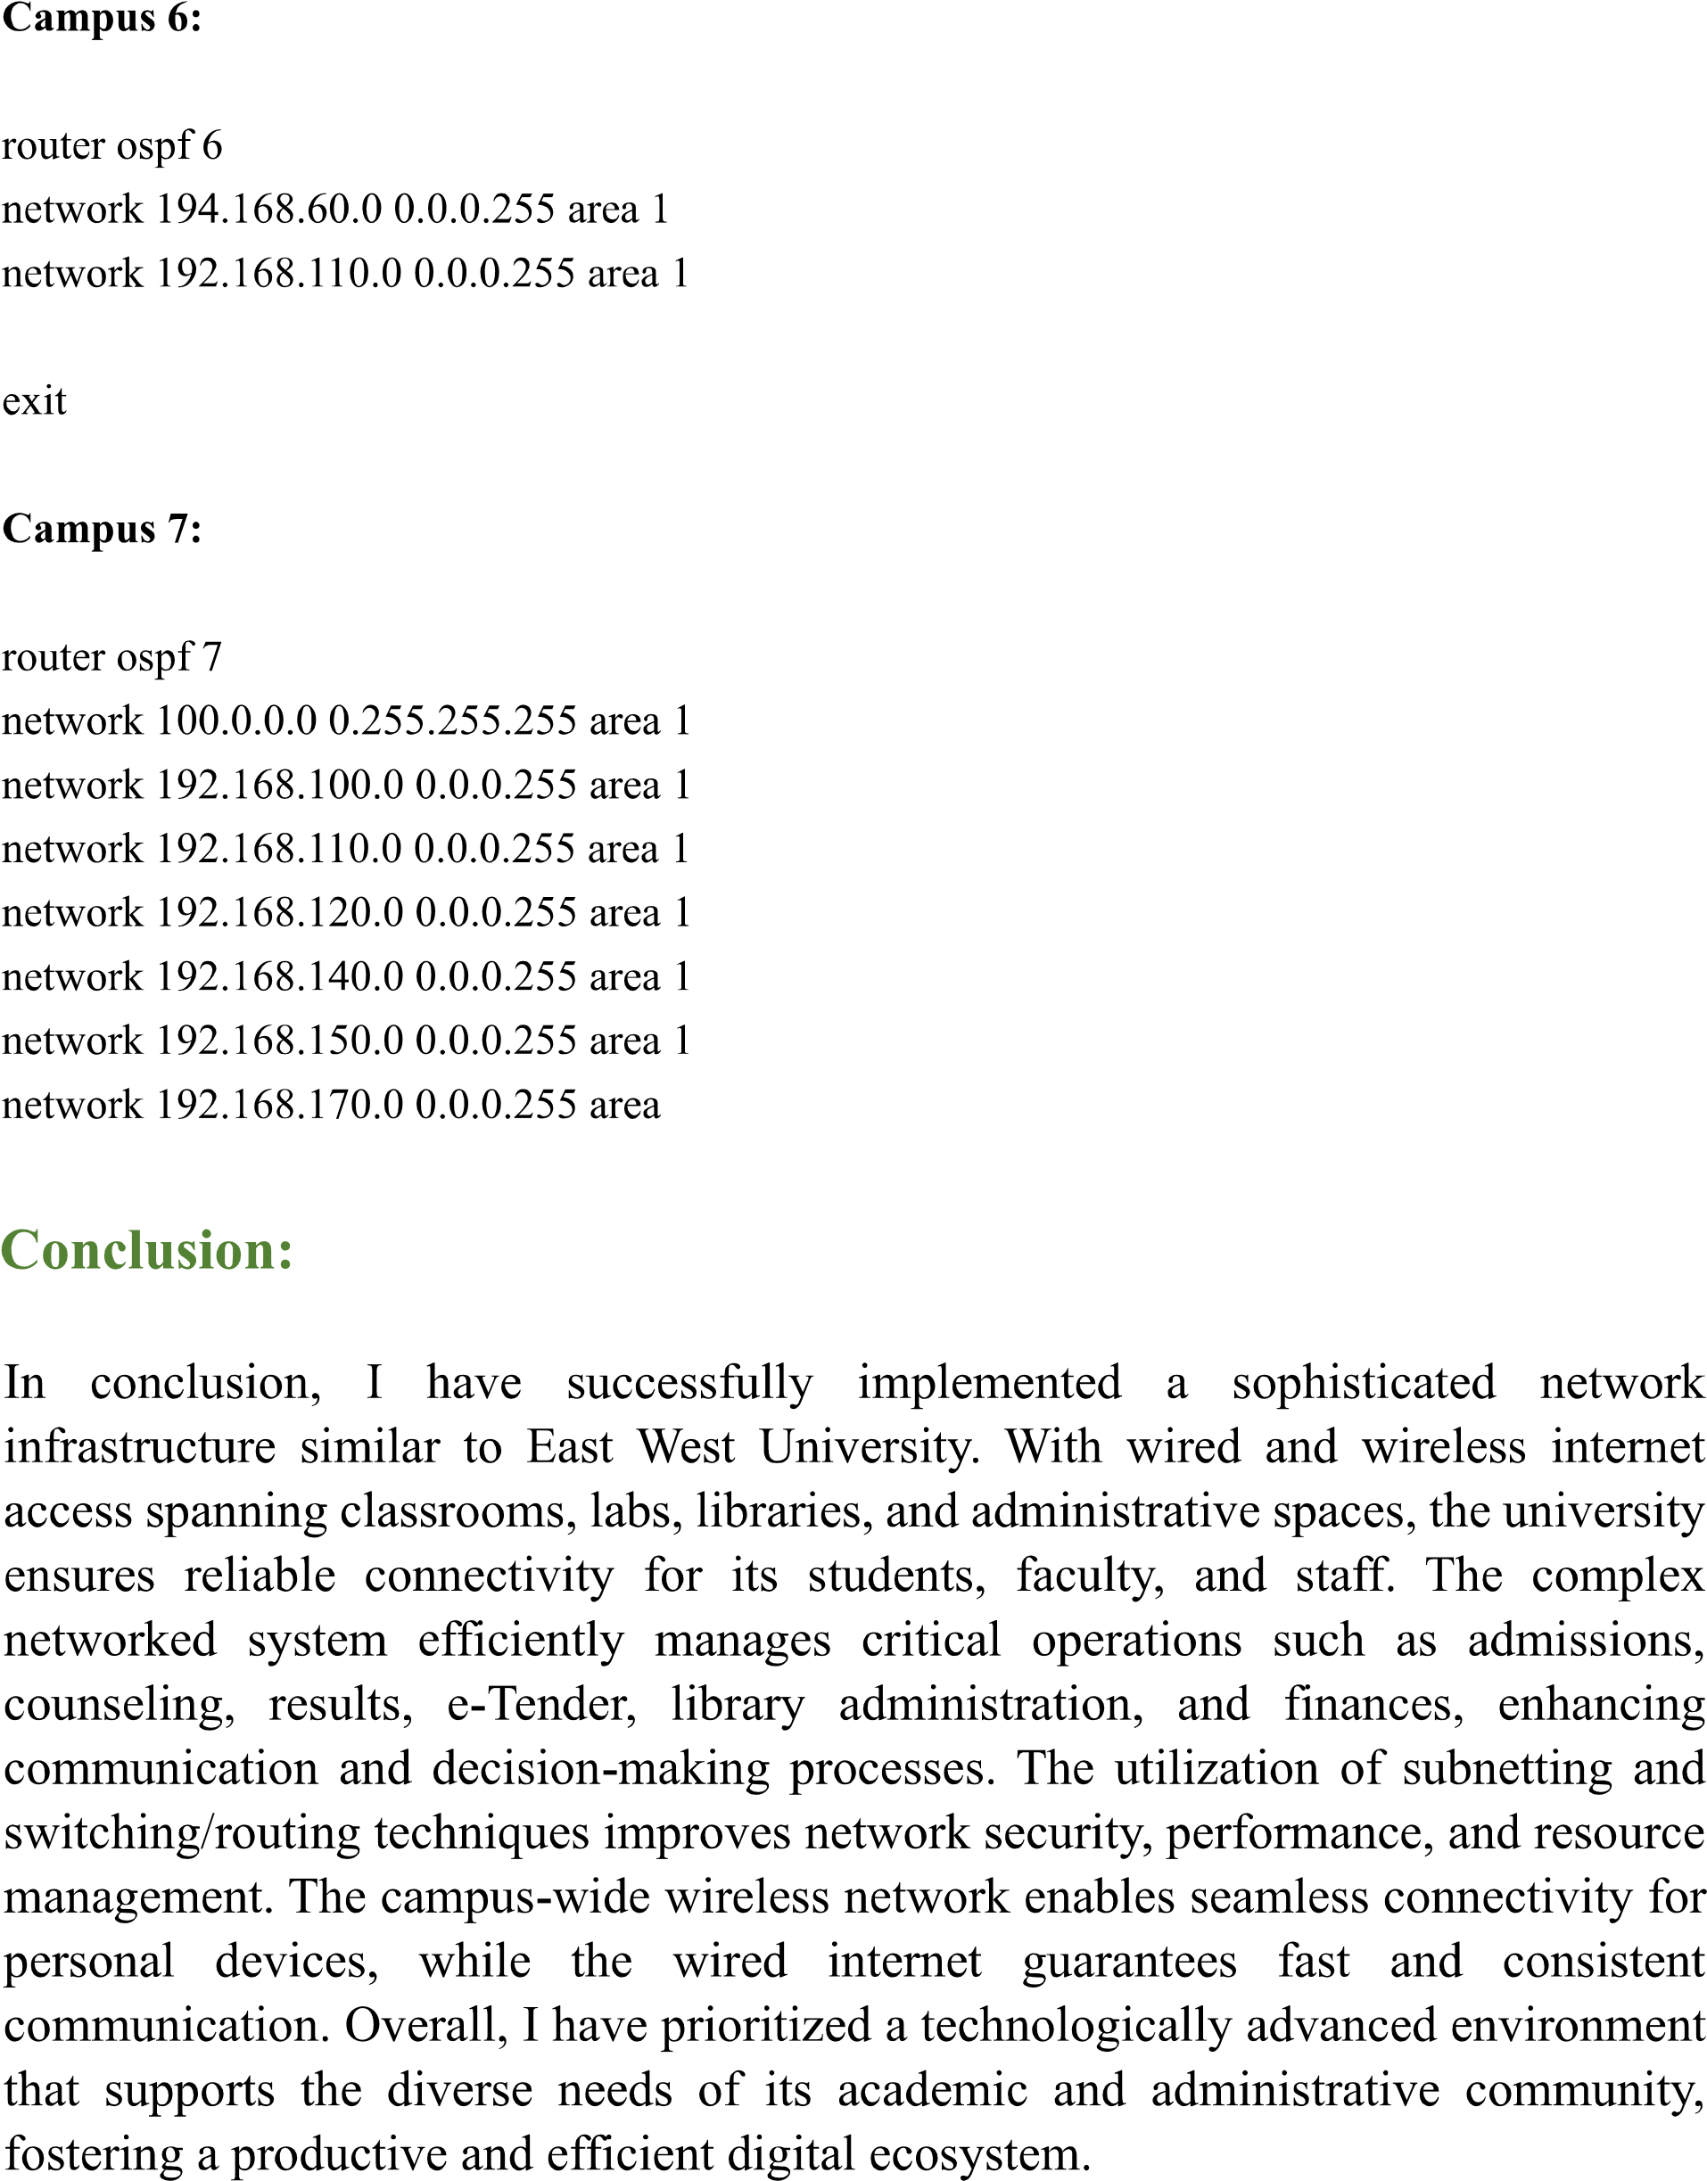

Campus 1: Campus 1 is for Server Room.

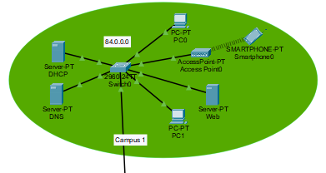

Campus 2: Campus 2 is for the Employee's Room.

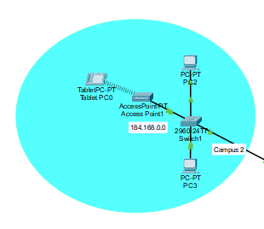

Campus 3: Campus 3 is for Library.

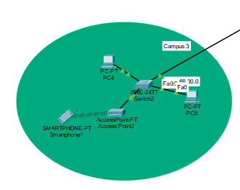

Campus 4: Campus 4 is for Labs.

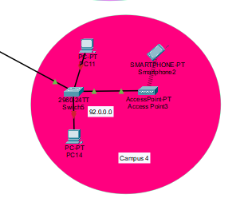

Campus 5: Campus 5 Faculty & Department Rooms.

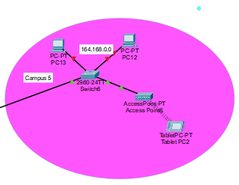

Campus 6: Campus 6 is for Classrooms

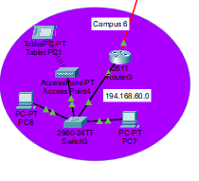

Campus 7: Campus 6 is for Admission Office.

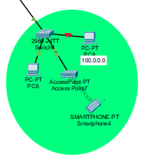

**Server Configuration:**

**DHCP Server:**  [IP: 84.0.0.254]

DHCP can serve IP across the network automatically. We use 1 DHCP server for 7 campuses. When a device is requested DHCP server can serve a unique IP address according to their Campus network.

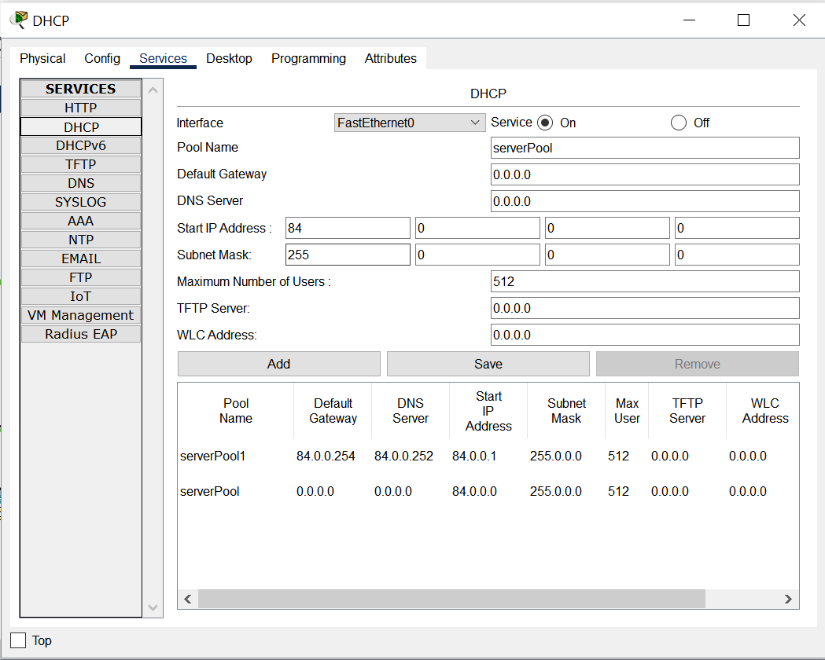

Figure 10: DHCP Server

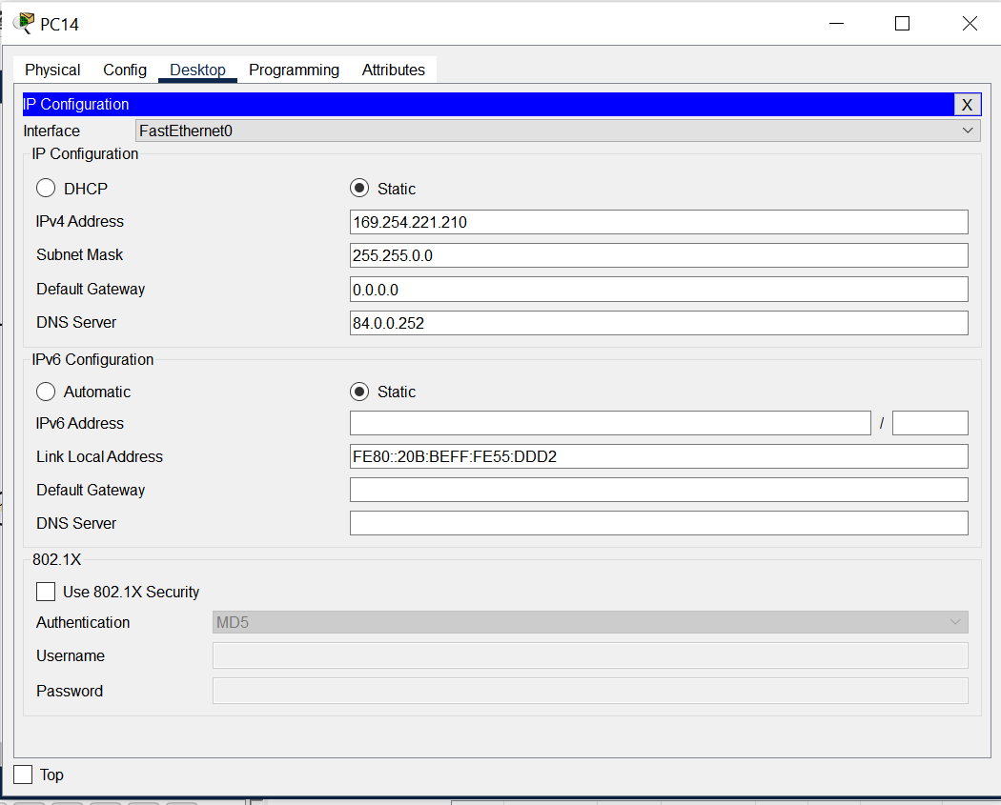

Figure 11: DHCP successfully giving Ip

**DNS Server:** [IP: 84.0.0.253]

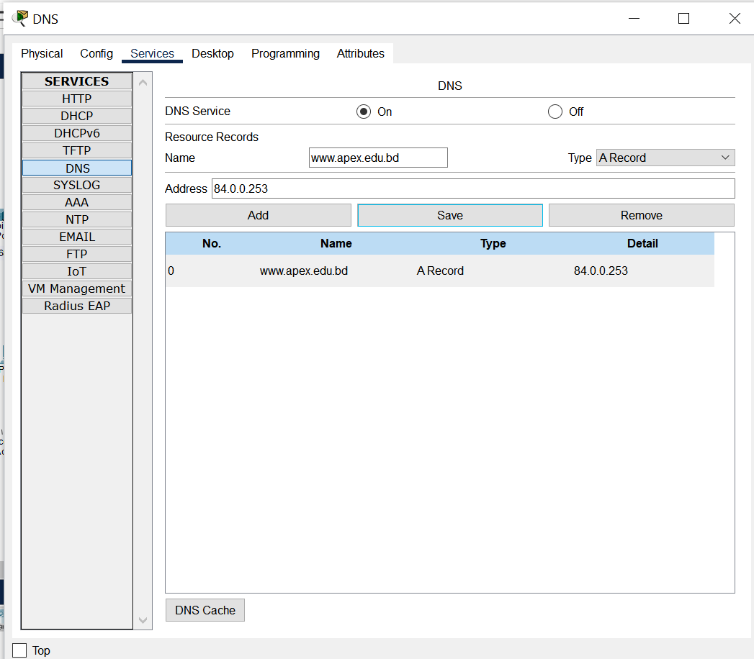

Figure 12: Config DNS Server

**WEB Server:**  [IP: 84.0.0.253]

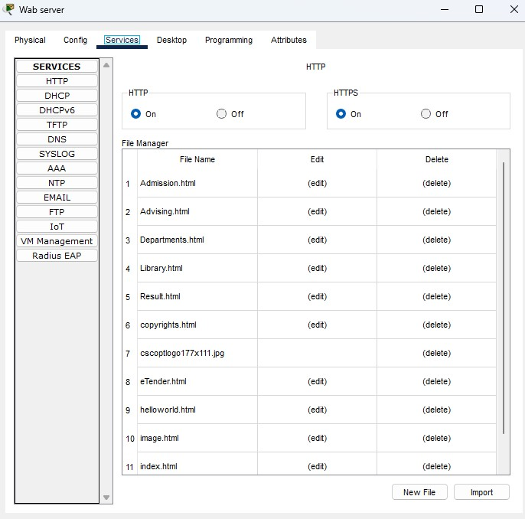

Figure 13: Config WEB server

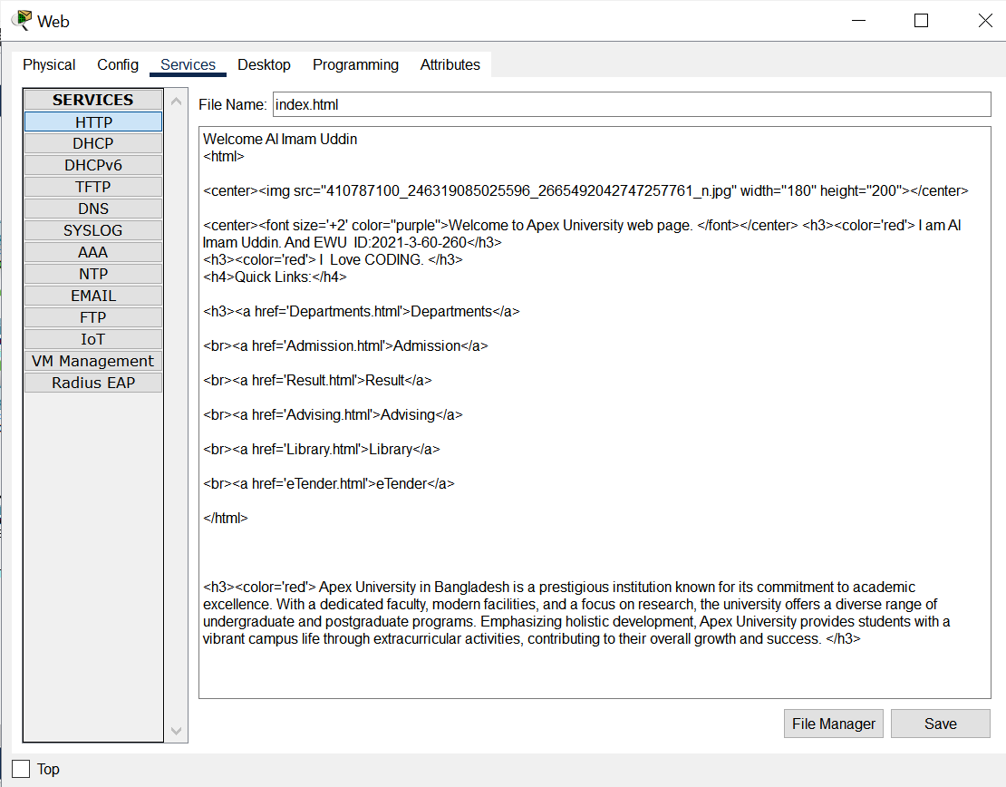

Figure 14: HTML code to Edit Home page

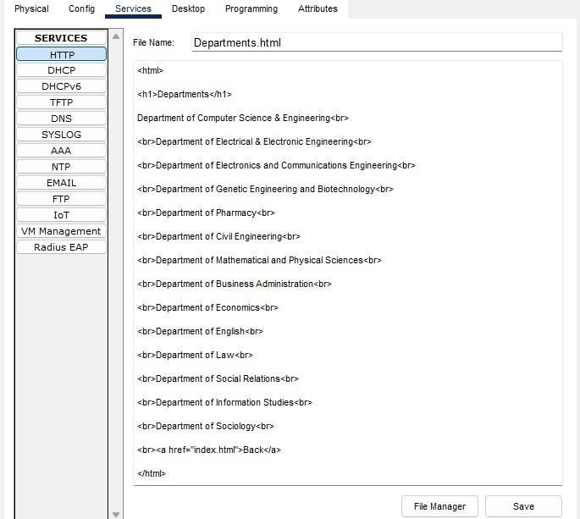

Figure 15: HTML code to Edit Department page

**University’s Homepage Access**

By writinghttp://www.apex.edu.bdOR 1.0.0.3 in Web browser.

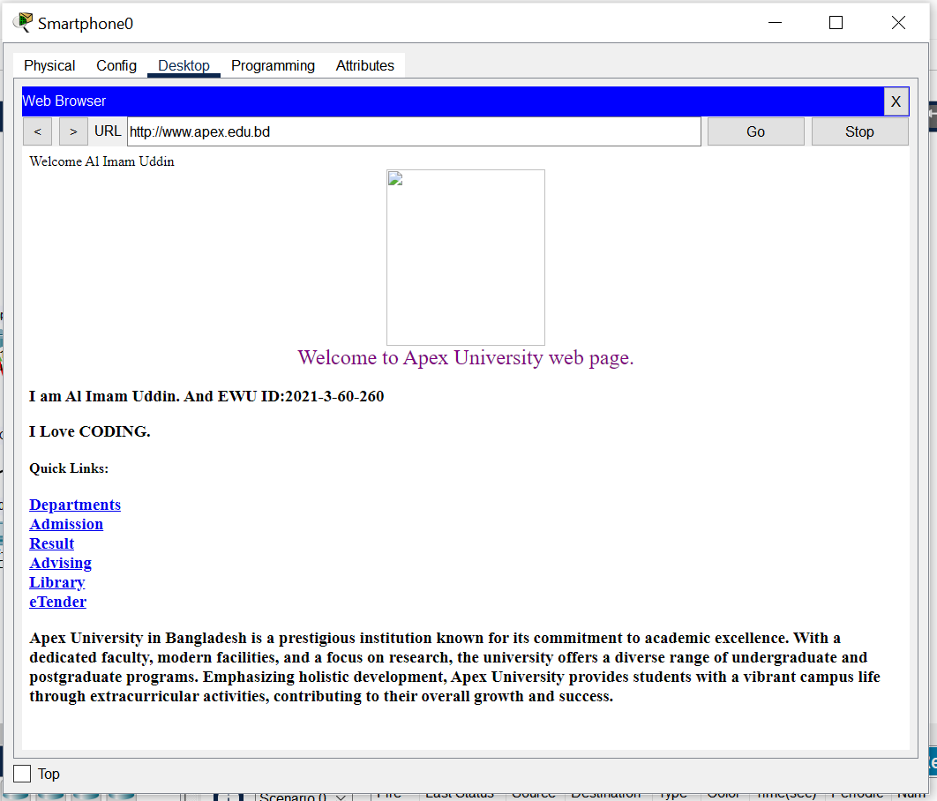

Figure 16: University’s Home page

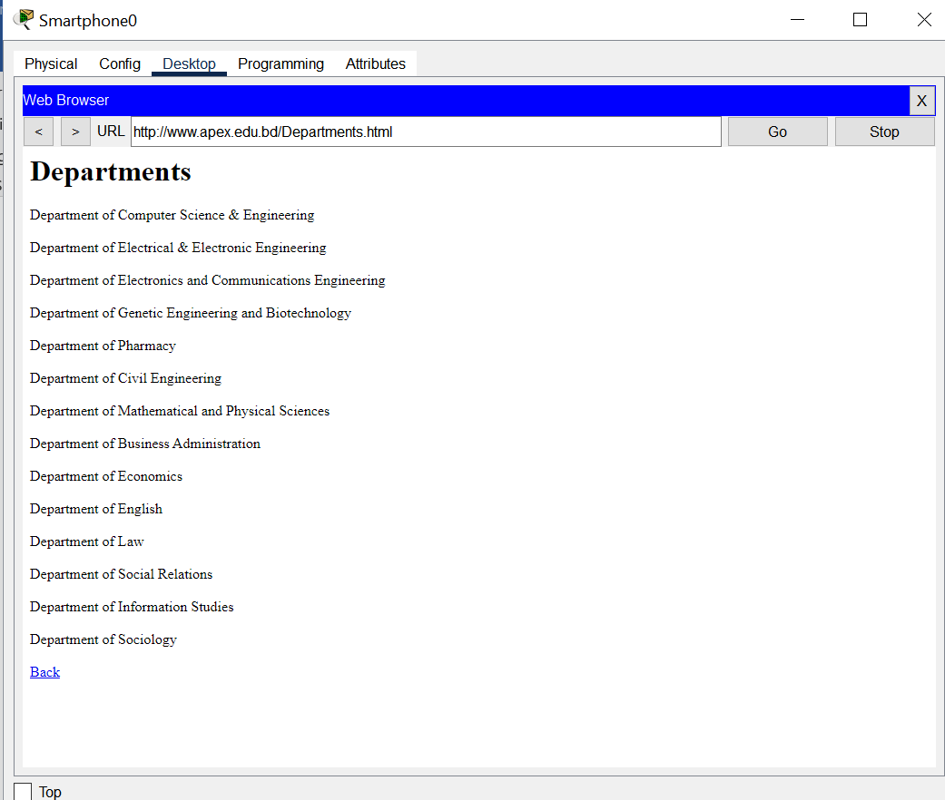

Figure 17: University’s Department page

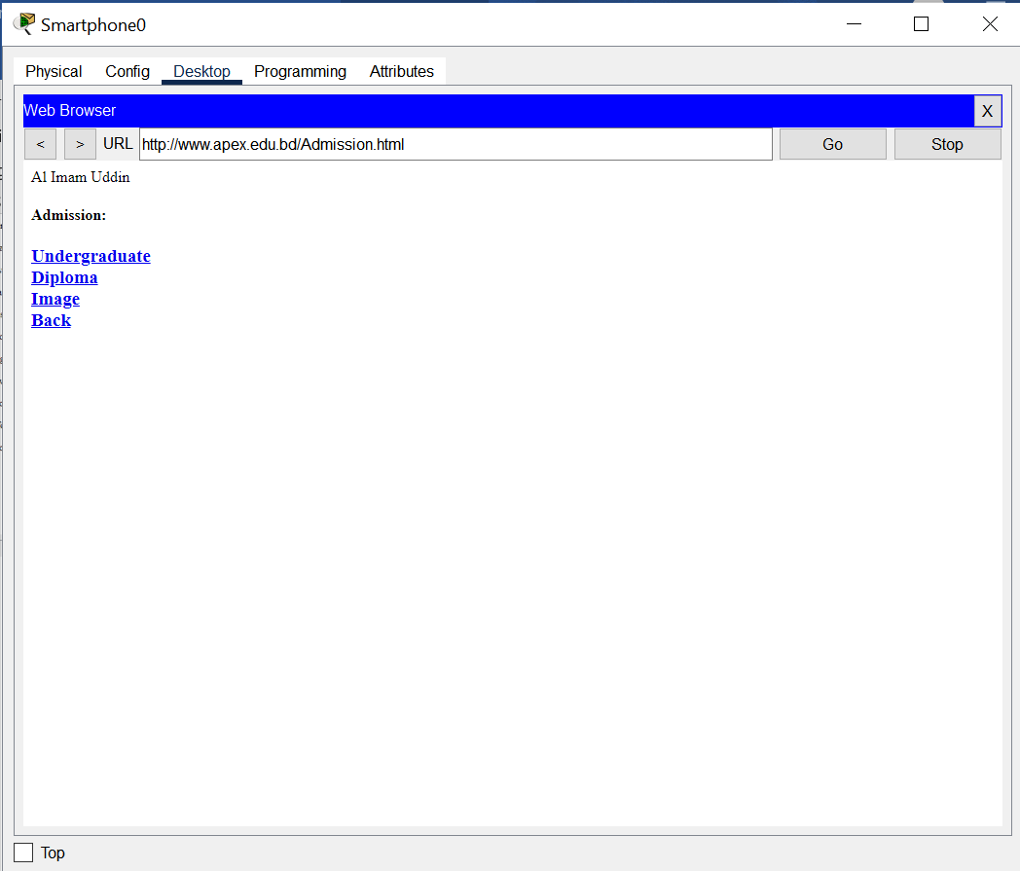

Figure 18: University’s Admission page

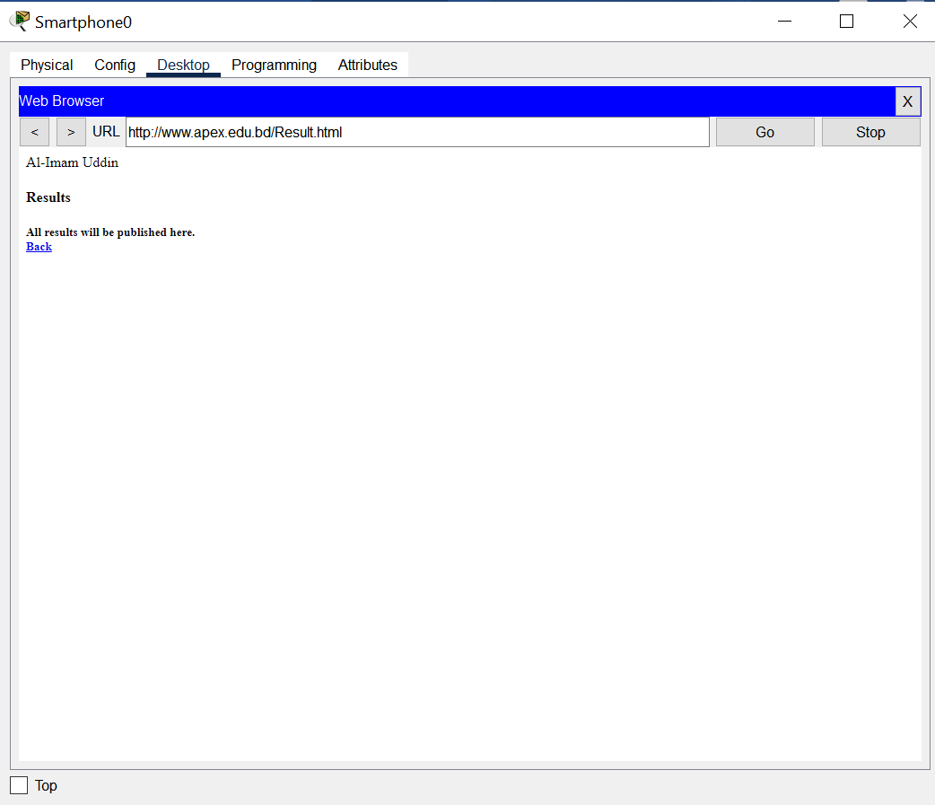

Figure 19: University’s Result page

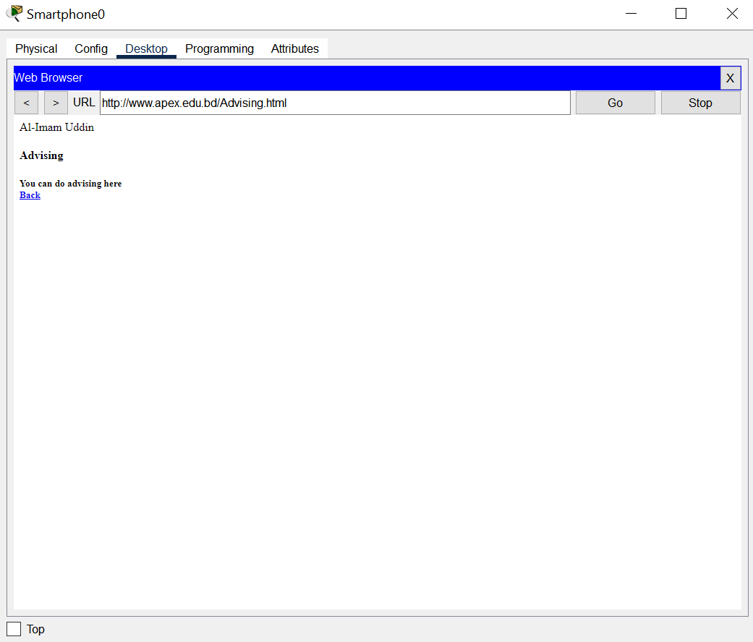

Figure 20: University’s Advising page

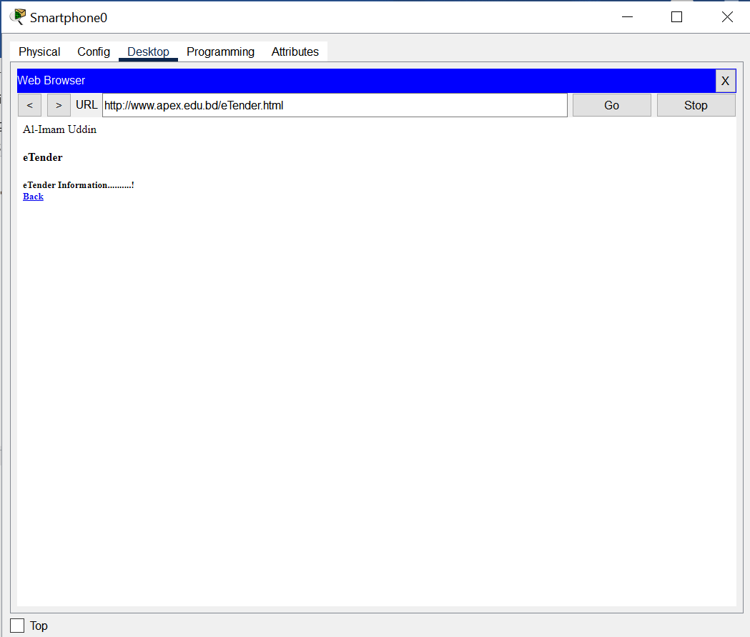

Figure 21: eTender page

**Ping between 2 PC (Same network):**

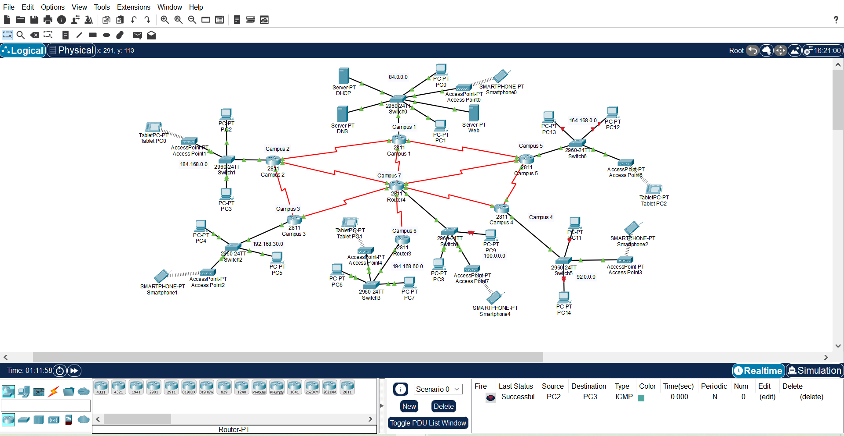

Figure 22: Sending ICMP packet in same network

**Ping between 2PC (Different Network):**

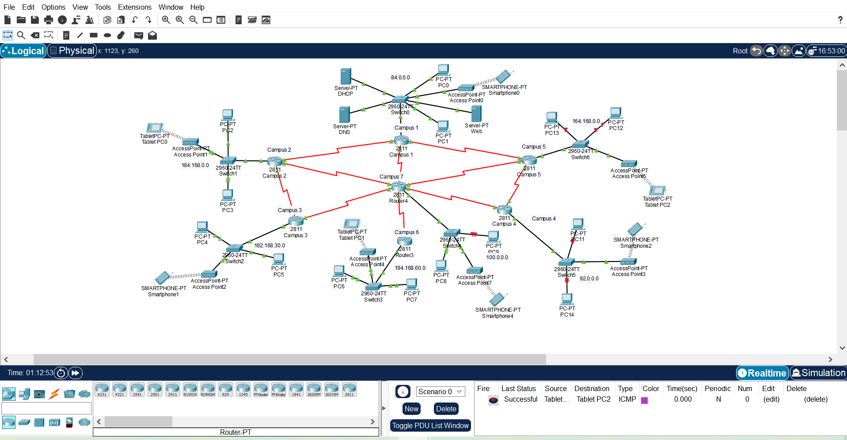

Figure 23: Sending ICMP packet in different network

**Wireless Device:**

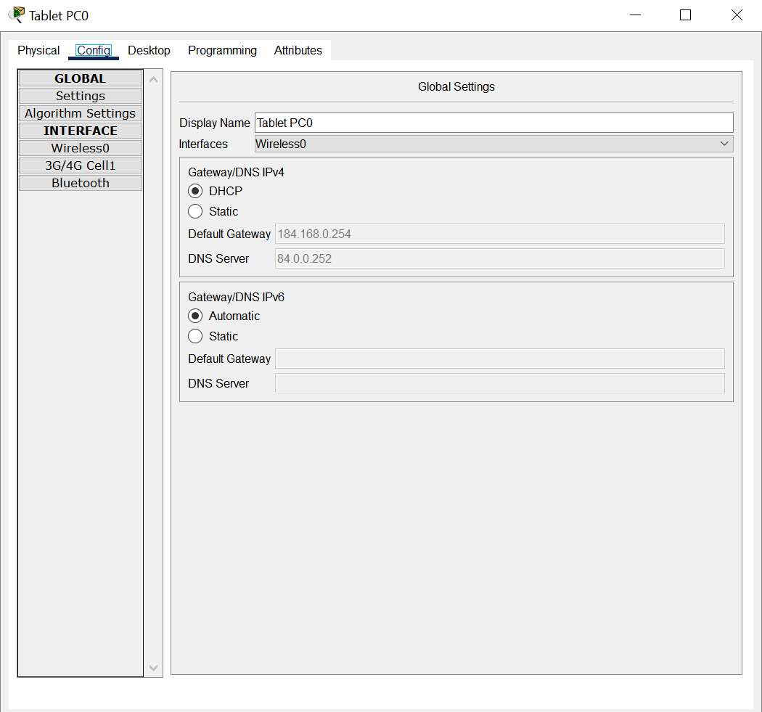

Figure 24: Config wireless device Laptop

**Conclusion:**

To complete the project flawlessly, I tried my best. Through the use of devices including computers, switches, routers, and wireless routers, I was able to fully simulate an intricate network for this assignment. Without any issues, all of these devices were able to communicate with one another via the network. To display the University's internet page, I also configured a dedicated server. With HTML, a unique type of code, I even altered the website's appearance. When a computer needs an IP address, I added a system that assigns them all a unique number. From this course and assignment, I gained a lot of knowledge.